**Detailed dataset information sheet**

|  |  |
| --- | --- |
| **Information Objective** | Assets and Environments |
| **Data Products** | Land Use |
| **Information Source / Model Product** | ABARES: CLUM Sep 2017 |
| **Product Completion Progress** | Early Stage |
| **Dataset / Metadata Document** |  |
| **Dataset Use** | Surveillance Strategy and Design, Data61 CISRO project |

**Background**

A national Citrus growing regions layer was requested for use within mapping products in response to the Citrus Canker incursions in the Northern Territory and Western Australia.

This layer was also requested by the Data61 unit of the CSIRO to assist with their analysis project.

**Dataset Procurement Process**

In the first instance, the Catchment scale Land Use of Australia – Commodities (CLUMC) datasets developed by ABARES were deemed to be the most authoritative national dataset from which to extract this information.

The commodity and land use classification codes within the Australian Land Use and Management Classification Version 8 (ALUM v8) guideline document were used to filter the CLUMC dataset for citrus land use.

The codes used are:

* 348 - Citrus—where citrus can be detected, map under this class rather than 3.4.1,

‘Tree fruits’.

* 448 - Irrigated citrus—where irrigated citrus can be detected, map under this class rather than 4.4.1, ‘Irrigated tree fruits’.
* 512 - Shadehouses—land where special purpose shade structure have been built for intensive plant production (including mushrooms). If the land use is known to be production nurseries, use 5.1.1 and the management description ‘semi protected’. If hail or bird nets are temporarily erected for orchards or similar, this does not constitute a land use change, so continue to map to the appropriate perennial, seasonal, or irrigated horticulture class.

Codes 341 and 441 could be used but contain a broader range of orchard type plantations including pome, banana, mango and stone fruit.

**Quality Check**

Some states such as Victoria mapped their data to the commodity description level such as citrus, oranges, lime, mandarin, lemon and grapefruit, while others only mapped to the broader ALUM v8 land use codes only. Other states mapped commodities such as vegetables to these codes.

The dataset was re-projected to an Australian Albers format and the area in hectares of these “Citrus” land use polygons was calculated for each state and is detailed in Table 1.

A second dataset was sourced from the Australian Bureau of Statistics (ABS) to cross reference the CLUMC citrus layer dataset.

The product **71210DO002_201617 Agricultural Commodities, Australia–2016-17**, contained information on the quantity of individual trees present in each state within the Citrus category.

This number was then divided at the medium density rate of 300 trees per hectare as described by [Citrus Australia](https://www.citrusaustralia.com.au/news/latest-news/higher-densities-could-boost-fruit-yields).

The CLUMC data for Victoria was relatively close while the rest of the states did not match up with the ABS data (Table 1).

The states have vastly different levels of information capture and commodity description attribute association with each farm.

New South Wales and Queensland data performed poorly and they did not capture useful commodity description level information.

Other States like South Australia mapped two tree type attributes (e.g. oranges and pistachios) against the same polygon and Western Australia has no state level dataset. This is currently being compiled internally by ABARES.

Table 1. Summary of the datasets and their completion status to date

|  |  |  |  |  |
| --- | --- | --- | --- | --- |
|  | **ABS 2016-17 - # of Citrus Tree** | **Area in Hectares @ 300 Trees/Ha** | **CLUM Data (Hectares of codes 348, 448 & 512)** | **CLUM as Percentage of ABS** |
| **Australia** | **10,996,394** | **36,655** | **10,919.96** | **29.79%** |
| Queensland | 1,950,810 | 6,503 | 666.35 | 10.25% |
| Victoria | 1,300,700 | 4,336 | 4053.54 | 93.49% |
| New South Wales | 4,594,182 | 15,314 | 44.44 | 0.29% |
| South Australia | 2,539,606 | 8,465 | 6004.21 | 70.93% |
| Western Australia | 605,169 | 2,017 | 15.71 | 0.78% |
| Tasmania | 18 | 0 | 2.71 | 4516.67% |
| Northern territory | 5,909 | 20 | 133 | 675.24% |
| Australian Capital Territory | 0 | 0 | 0 | 0.00% |

Discussion and Future Work

There is an inherent dilemma in deciding which dataset to use as the point of truth as there are significant inconsistencies between the two.

In comparison, ABARES’ CLUMC dataset has been compiled from individual state level datasets whereas the ABS information is derived from a geo-coded source dataset of actual farm locations derived from the Australian Business Register.

An attempt was made to obtain this dataset from the ABS but the contact in the Environment and Agriculture Statistics Branch Statistical Delivery and Communication Section advised that this could not be released due to confidentiality restrictions.

It would appear that the ABS dataset would likely be more representative of the true extent of citrus growing regions then the individual state level land use mapping programs.

If we take the ABS data as the initial point of truth, the CLUMC dataset is not consistent enough to use at a national level in its current form.

To improve this dataset a number of refinement options can be pursued each consuming more in labour and time resources. These processes can be readily transferred across any commodity type to assist in improving the completeness of the ABARES CLUMC dataset if a commodity of interest is found to have the same quality and completeness issues.

**Processes**

1. The quickest and least costly process by which this can be achieved would involve contacting the national growers association for the commodity in question, e.g. Citrus Australia and:
   1. Request a list of farm locations (street address or GPS coordinates)
   2. Geo-code if needed and convert this data into a Google Earth KML layer
   3. Use the locations as a guideline for identifying citrus orchards visually (using satellite imagery as recent as 2017 and in the 60cm to 1 metre resolution range)
   4. Map the citrus fields by drawing a polygon around those which appear to contain citrus
   5. Save the information to a KML file
   6. Import this file back into ESRI’s ArcMap software
   7. Converted the dataset to an Australian Albers projected grid
   8. Re-calculate the area in hectares for each cell
   9. Compare results to the ABS dataset
   10. Once quality level is acceptable feed this data layer back to ABARES CLUMC unit for updating
2. A more thorough process by which this can be achieved would first involve contacting the national growers association for the commodity in question, e.g. Citrus Australia and:
   1. Request a list of farm locations (street address or GPS coordinates)
   2. Geo-code if needed and convert this data into a Google Earth KML layer
   3. Use the locations as a guideline for identifying citrus orchards visually (using satellite imagery as recent as 2017 and in the 60cm to 1 metre resolution range)
   4. Map the citrus fields by drawing a polygon around those which appear to contain citrus
   5. Save the information to a KML file
   6. Import this file back into ESRI’s ArcMap software
   7. Apply a buffer around the polygons and dissolve into larger contiguous sections
   8. Contact each state department and ask them to provide their most up to date aerial imagery which covers the area of these contiguous polygon blocks (usually this imagery will be in the 15cm to 25cm resolution range)
   9. Use the aerial imagery to further refine the citrus polygons layer
   10. Map the citrus fields by drawing a polygon around those which appear to contain citrus
   11. Re-calculate the area in hectares for each cell
   12. Compare results to the ABS dataset
   13. Once quality level is acceptable feed this data layer back to ABARES CLUMC unit for updating
3. If datasets from national growers associations cannot be obtained, a manual digitisation process can be undertaken:
   1. Convert the existing CLUMC dataset to a Google Earth layer
   2. Use these polygons as guidelines to visually scan for citrus orchards within the available satellite imagery
   3. Use the Google Maps and Google Search engine to further identify citrus orchards such as Hillsdale Citrus Orchard located in Bulga, New South Wales (Figure 1)
   4. Digitise the citrus fields into polygons with Google Earth (Figure 2)
   5. Where available use Google Maps “street view” tool to visually confirm orchard is of a citrus type (Figure 3)
   6. Save the information to a KML file
   7. Import this file back into ESRI’s ArcMap software
   8. Re-calculate the area in hectares for each cell
   9. Compare results to the ABS dataset
   10. Once quality level is acceptable feed this data layer back to ABARES CLUMC unit for updating

Figure 1. Hillsdale Citrus Orchard, Bulga, New South Wales in Google Maps “bird’s eye” view

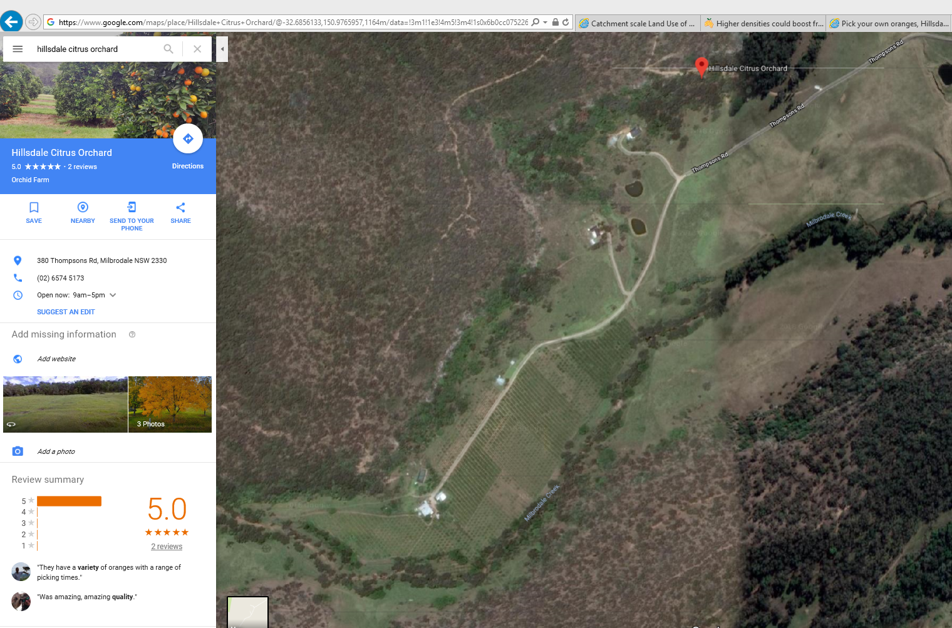

Figure 2. Hillsdale Citrus Orchard, Bulga, New South Wales digitised in Google Earth’s “bird’s eye” view

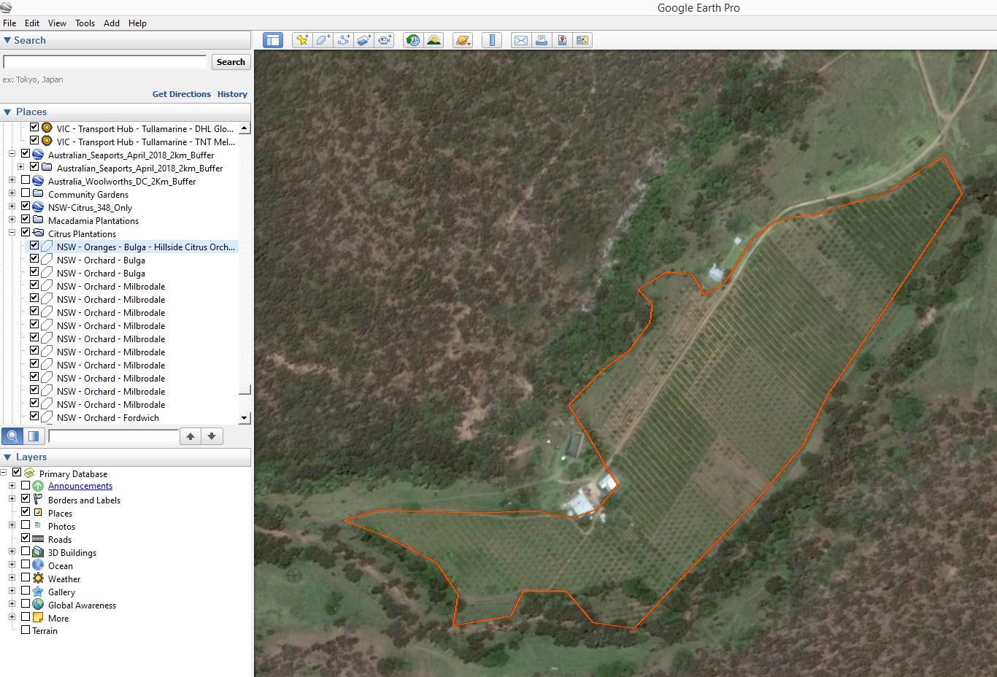

Figure 3. Ford’s Farm Citrus Orchard, Laughtondale, New South Wales in Google Maps “street view” tool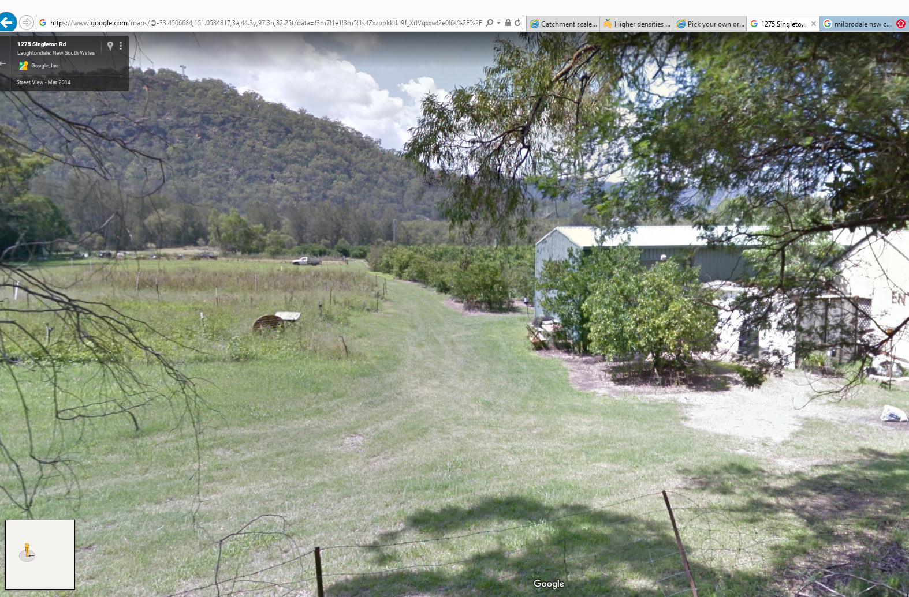

Project Resources Estimates and Uses

An estimate of the timeframes and data procurement requirements required to fix the CLUMC dataset as per the three processes outlined above are summarised in Table 2.

The end result will be a dataset which is superior to the current CLUMC product and can be referenced as a point of truth data source for input into projects such as surveillance strategy and design.

This dataset will provide accurate and useful de-personalised information such as:

* Farm locations
* Area sizes

And will assist in:

* Serving as an input in estimating labour and capital resources for conducting surveys for pests such as those in the National Priority Plant Pests (NPPP) target groups
* Mapping requirements for national/state emergency response programs that are deployed when these pest incursions occur.

Table 2. Comparison of process methods and output dataset quality expectations

|  |  |  |  |  |
| --- | --- | --- | --- | --- |
| **Process** | **Requires Industry Assistance** | **Requires State Government Assistance** | **Estimated time to complete** | **Expected Dataset Quality Level** |
| 1 | Yes | No | 1-2months | Authoritative |
| 2 | Yes | Yes | 3-4 months | Authoritative – superior to Process 1 and CLUMC |
| 3 | No | No | ~ 6 months | High to Authoritative – superior to CLUMC |